

**C3879C - Capstone Project**

**AY2022 Term 1**

**Coursework Final Submission**

|  |  |
| --- | --- |
| **Personal Details** | |
| **Name** | **Lim Zhao Hong** |
| **Student No.** | **20065320** |

|  |  |  |
| --- | --- | --- |
| **Compliance Statement** | | |
| **Plagiarism**  I declare that this report is my original work. I understand that if I am suspected of plagiarism, my enrolment in the programme may be terminated. | | **🗸** |
| **Retention of Backup Copy**  I declare that I have a back-up electronic copy of this report for immediate submission. | | **🗸** |
| **Signature** |  | |
| **IMPORTANT:** Non-compliance to these clauses will result in unconditional rejection of your submission | | |

Safety Helmet Detection

Date of Submission: 28-Apr-2023

Submitted By:

|  |  |
| --- | --- |
| 20065320 | Lim Zhao Hong |
|  |  |
|  |  |
|  |  |

# Table of Contents

Table of Contents 3

1. Abstract 4

2. Acknowledgement 5

3. Background 6

3.1 Project Overview 6

3.2 Problem Statement 6

3.3 Motivation 7

3.4 Project Scope 7

3.5 Project Deliverable 7

4. Methodology and Design 8

4.1 Project Methodology/Approach 8

4.2 Solution Design 8

5. Findings 9

5.1 Dataset 9

6. Evaluation and Analysis 10

6.1 Prediction of photo 10

7. Results 11

7.1 Prediction of safety helmet 11

8. Conclusion 12

9. Recommendations 13

10. Appendices 14

11. References 15

# Abstract

Injury at work can result in serious physical, emotional, and financial consequences for employees and employers alike and can be caused by a variety of factors such as equipment malfunction, human error, and environmental hazards. The impact of these injuries can be significant, including lost work time, medical expenses, and decreased productivity.

Workplace injuries prevention include implementing safety protocols and training programs, conducting regular inspections and hazard assessments, and fostering a culture of safety within the workplace. However, these may not adequately address safety concerns especially if the employees are not adhering to safety protocol.

The project idea is to detect personal protection equipment (PPE) is wore when required at the production site. It is identified to check if safety helmets are wore by the employees to reduce any chance of injury at workplace.

# Acknowledgement

I would like to express my gratitude to the lecturers for their guidance in Specialist Diploma in Applied Artificial Intelligence, especially to project advisor Jimmy Goh, who has provided advice towards the Capstone project completion.

This course has been very intensive, in term of study load and the time commitment for the past 1 years. At the same time, it is rewarding because the course demonstrates how to get started in the field of Artificial Intelligence. It is a field that require dedication, continuous learning, and constant coding to excel.

Finally, I would like to thank my colleagues with their support in this project.

# Background

## 3.1 Project Overview

Preventing workplace injuries is crucial, and employers have a responsibility to provide a safe working environment and take necessary measures to prevent accidents. However, employees have a part to play to ensure that they are wearing adequate and correct PPE (Personal Projection Equipment). The project aim to demonstrate the use of safety helmet in the area where it is required.

## 3.2 Problem Statement

Recent LTIF (Lost Time Injury Frequency) trends and accident have been escalating, which has to be improved. Among the top reason is due to Inadequate PPE protection or failing to wear PPE.   
  
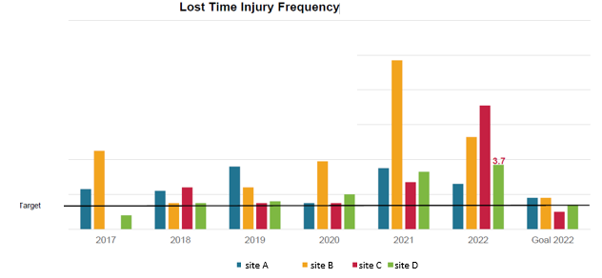

The objective of this project to harness computer vision to detect PPE violations to raise awareness and avoid/prevent repetition of these or similar accidents in future.

Therefore it is important to avoid and prevent repetition of these or similar accidents in future. Among the top reason that result in accident is due to Inadequate PPE protection or failing to wear PPE.

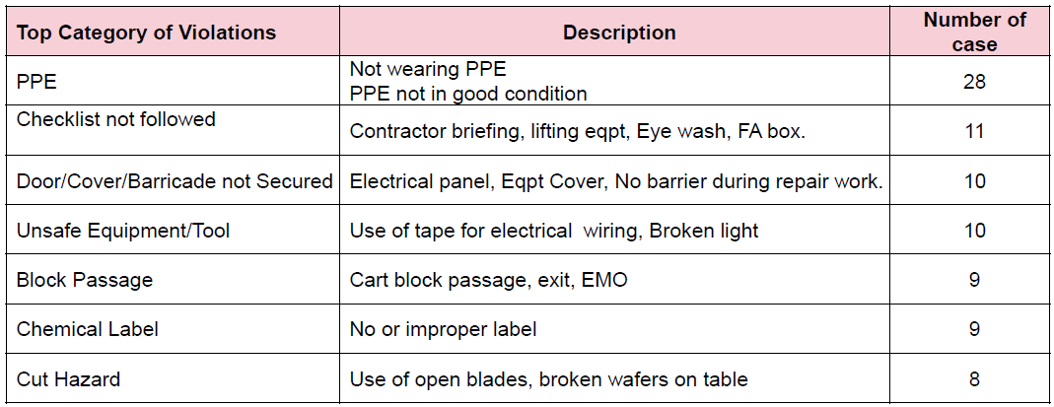

## 3.3 Motivation

It is aimed to enhance PPE detection as an aim to encourage employee to be mindful and consider personal safety, avoid/prevent repetition of these or similar accidents in future and to reduce LTIF (Lost Time Injury Frequency).

## 3.4 Project Scope

Due to internal request, there is a change in project scope. the original plan is to detect for missing desiccant bags in production but the EHS (Environment, Health and Safety) department is requesting to have Safety Helmet detection.

For a start, the project would take a series of images with people wearing and not wearing safety helmets (PPE) for training and validation purpose.

Transfer learning of the pre-trained model would be applied where safety helmet is required in those area.

## 3.5 Project Deliverable

The Objective of this project to harness computer vision to detect PPE violations to raise awareness and avoid/prevent repetition of these or similar accidents in future. The deliverable is create a computer vision detection system to ensure that employees are donning their safety helmet where required.

# Methodology and Design

## 4.1 Project Methodology/Approach

Knowledge of Python, Deep learning concepts, and Computer Vision is required to process data and get an optimized pre-trained network. With the pre-trained network, it would be further deployed in actual scenario.

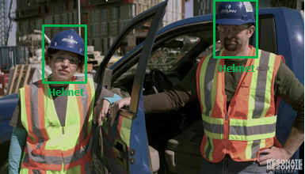 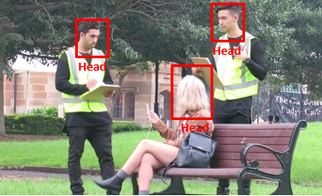

YOLO, which stands for "You Only Look Once", is a popular real-time object detection system that was first introduced in 2016. Since then, several versions of YOLO have been released, each with its own improvements and enhancements. YOLOv8 is currently the latest version and is a deep neural network that can detect and classify objects in real-time video streams or images. The system is based on a single convolutional neural network (CNN) that processes the entire image at once, rather than breaking it down into smaller parts. This approach allows for faster processing and more accurate object detection than traditional object detection systems.

## 4.2 Solution Design

A series of stock photos would be selected to ensure that pre-trained model work in different environment. Using image classification and segmentation in Roboflow, the model would detect if safety helmet is wore  
If there is detection that safety helmet is not wore, a notification would be triggered to the respective department to confirm and investigate.  
  
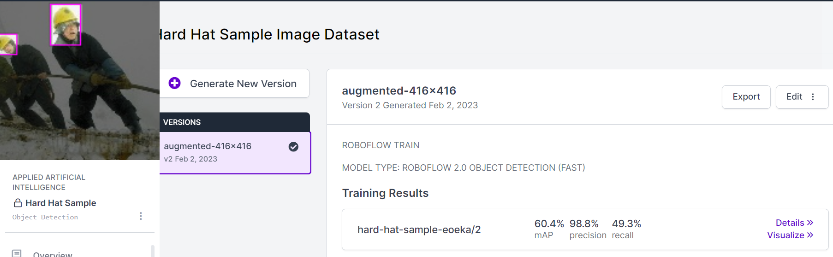

# Findings

## 5.1 Dataset

Data would be collected via photos of cassettes with / without safety helmet for training  
  
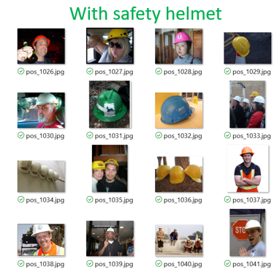 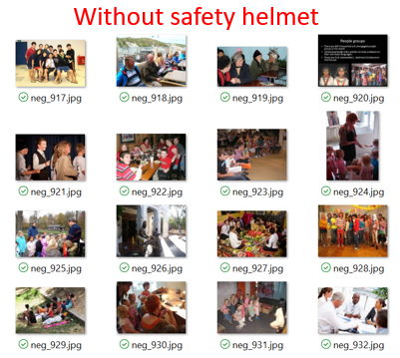

# Evaluation and Analysis

## 6.1 Prediction of photo

Roboflow is used to train for safety helmet detection. However, the accuracy is still lacking in actual scenario. More photos of head required for training.

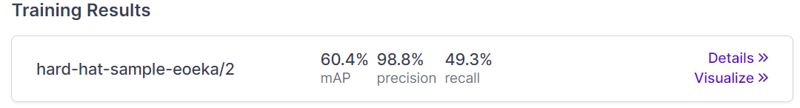

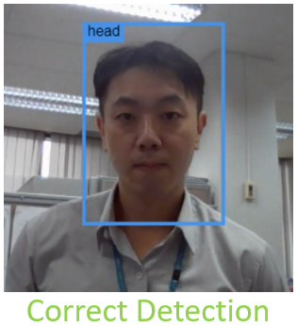 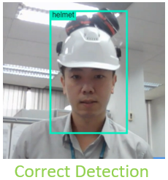 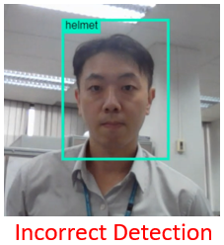

The alternative model is sourced from Ultralytics (yolov8m-protective-equipment-detection, n.d.). This model is tested for accuracy.

# Results

## 7.1 Prediction of safety helmet

# Conclusion

The *Conclusion* section of the reporting template gives the main cause(s) of the problem or opportunity highlighted by the project. It provides a summary of the discussions made in the Key Chapters, outlines the main findings, and gives a reference to the Recommendations report section.

# Recommendations

The *Recommendations* section of a sample projector report is designed to call people to action based on the findings, analyses and results that have achieved upon project completion. It should be written with actionable and specific sentences and give a solution for the problem investigated by the project.

# 10. Appendices

The *Appendices* section of a typical project reporting document includes any other material in support of project findings. Gantt Charts, Resource Usage Diagrams, Project Schedule Template, Issue Log.

# 11. References

The final section of your report covers all the sources of information used to make the research and develop the document.

1. https://huggingface.co/keremberke/yolov8m-protective-equipment-detection